**PySpark Assessment 3 :** - Abhiram Basa

We started with Basic commands in Pyspark,

First we need to start by initializing the spark shell.

**Command: Spark-shell**

We need to enter this command in the cmd to start a spark shell.

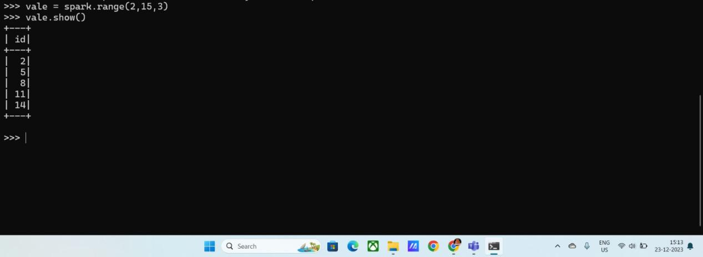

**Range():** This will create an array in pyspark from range 2 to 15 with a step value 3.

**Value.show():** This will print the output the screen.

**Parallelize():**

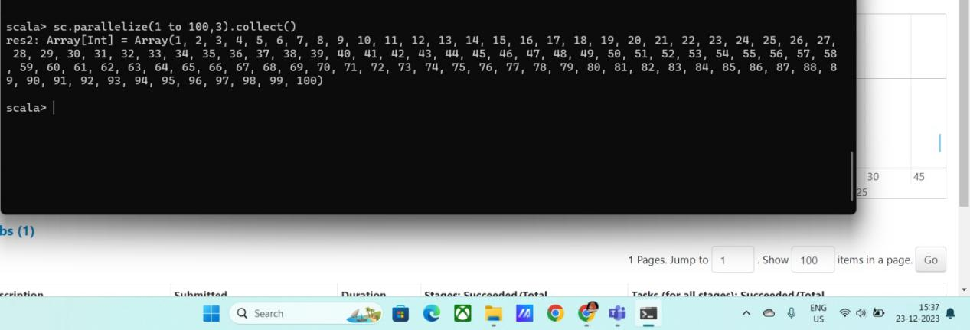

**Read.csv():** This will read the file which is in csv format.

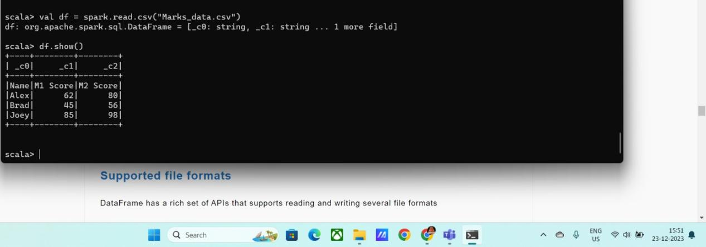

**Spark.Session.builder.appName(“name”):** sets a a name app.

**Spark.session.builder.getOrCreate():** Creates or returns an existing Spark session.